HSV Color Model

What is color?

* The word **"color"** refers to the visual perception created by the way an object reflects or emits light. It's how our eyes and brain interpret different wavelengths of light.
* Color is a **property of light** determined by its **wavelength** in the visible spectrum
* For example:
* **Red**: ~620–750 nm
* **Green**: ~495–570 nm
* **Blue**: ~450–495 nm

What is color model?

A color model can be defined as a system,which makes use of the three primary colors(rgb),to produce a vast range of colors.there are many color models used in the technology sector and each of them have certain purposes and different from each other.the range of colors which can be produced by deploying any particular color model is referred technically as a color space.

The different color models are:

-RGB

-CMY

-HSV

-YIQ

RGB and CMY color model:

These are the **primary colors of light**, and by mixing them at different intensities (usually from 0 to 255), we can create **millions of colors**.

* + R-Red
  + G-Green
  + B-Blue
  + Primary colors are used to produce the secondary colors as and when required
  + There are two color model-Additive and Subtractive models.

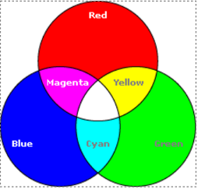

CMY:

It is a subtractive color model, which means it works by removing light from white

* + C-Cyan
  + M-Magenta
  + Y-Yellow

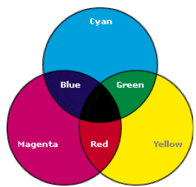

Hue,Saturation,Value:Cylinder!

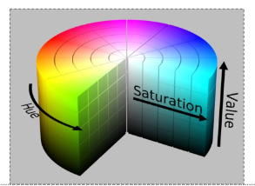

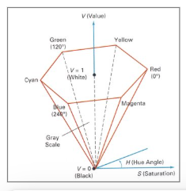

HSV converted image

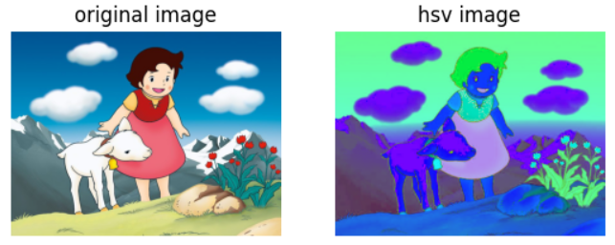

How do Artists do it?

* Artists often specify color as tints,shades and tones of saturated(pure) pigments.
* Tint:gotten by adding white to a pure pigment,decreasing saturation.
* Shade:gotten by adding black to a pure pigment,decreasing lightness.
* Tone:gotten by adding white and black to a pure pigment.

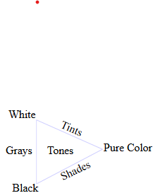

Why is HSV used?

* It separates the color itself from the brightness and intensity
* It makes it easier to detect and filter colors in image.
* It works when lighting changes(like shadow or brightness).
* Why HSV is often preferred over RGB?
* Separation of color and intensity.
* **HSV** separates **color (hue)** from **brightness (value)** and **colorfulness (saturation)**.
* **RGB** mixes color and brightness, making it hard to isolate just the hue or shade.

Where is HSV used?

• **Image Processing** (OpenCV, computer vision)

* To detect specific colors (e.g., red ball, yellow line)

• **Object Tracking**

* Easier to track a colored object using hue

• **Color Pickers**

* In design software like Photoshop or web apps

• **Skin or face detection**

* Better accuracy than RGB

• **Underwater or low-light color detection**

* Because it separates brightness from color